
Beating Breast Cancer

William Hobbins, MD, FABS, DABCT, FIACT

William Amalu, DC, DABCT, DIACT, FIACT

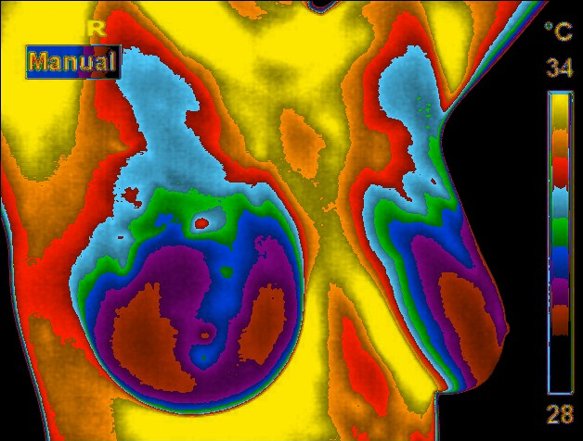
This year, over 192,000 women will be diagnosed with breast cancer in the US and 1.2 million worldwide (Source: American Cancer Society and WHO). As shocking as these numbers are, even worse is the number of cancers that won’t be detected until it’s too late. The consensus among experts is that early detection holds the key to survival. Although this is true, early detection can be elusive. Even though women are advised to begin having mammograms at 40, what they don’t know is that by the time most cancers are detected they have been growing for up to 10 years, and that 20% of all cancers can’t be seen by a mammogram. It is because of these factors, and others, that the number of women who die from this disease has changed very little in the past 40 years.

If a significant change in breast cancer mortality is to be realized, we have to rethink how we are providing for early detection. Are we currently providing a system that includes an early warning? What if we had a system that would comprise a multimodality approach that includes technologies that reflect the early cancerous process itself? If there were a method of very early detection, a procedure that may act as an early warning system, women would have an additional tool to give them the fighting chance they need to win this battle. What is needed is a risk marker. We may be able to turn these statistics around if a risk marker were added to a woman’s regular screening procedures. Women now have access to a unique technology that may give them this early risk marker; a procedure called Digital Infrared Imaging (DII).
If there were a method of very early detection, a procedure that may act as an early warning system, women would have an additional tool to give them the fighting chance they need to win this battle.

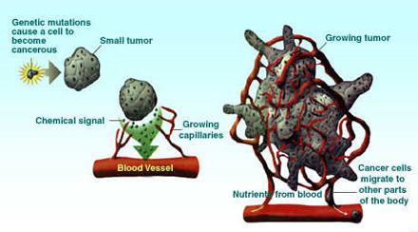DII is a technology that uses advanced high-resolution computerized medical infrared camera systems to detect and analyze thermovascular heat patterns from the surface of the breasts. When a cancer is forming it incorporates and develops its own blood supply in order to feed its growth (a process known as angiogenesis). Even more important, pre-cancerous tissues may start this process in advance of the cells becoming malignant. This increased blood supply causes an abnormal heat pattern in the breasts. DII can detect this abnormal heat pattern by using specialized infrared cameras and sophisticated computerized analysis under the guidance of a doctor who is board certified in the procedure. These abnormal heat patterns are among the earliest known signs of risk that a cancer may be a forming.

An increased level of early detection may be realized when DII is added to a woman’s regular breast health care. It has been found that an abnormal thermal image is the single most important sign of high risk for developing breast cancer, 10 times more significant than a first order family history of the disease. This gives DII the ability to act as a possible risk marker; thus, warning a woman about her own unique level of future risk for breast cancer.

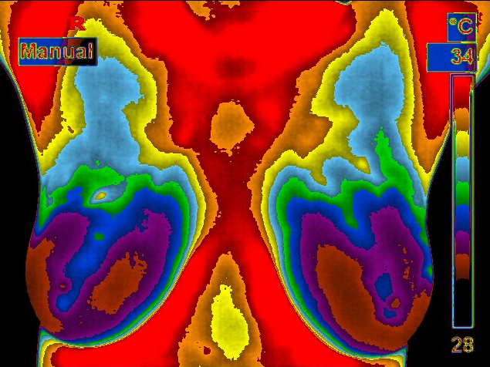
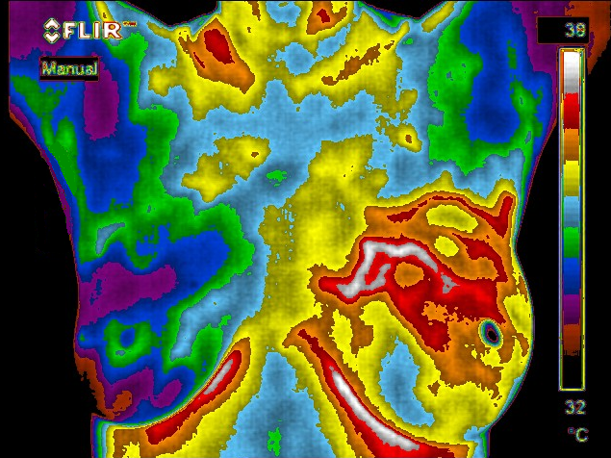
Women who undergo the test find it to be fairly uneventful, since the procedure is completely harmless and there is no contact with the breasts. Women with dense breasts, implants, and women who are pregnant or nursing can be imaged without any harm or reduction in the accuracy of the test. Normal images, like the one seen on the left, show evenly cool inactive breasts (dark colors represent cold areas). Abnormal images, as seen on the right, show highly active blood vessels giving off heat in one breast. Since the procedure does not pose any harm to the patient, women who are at higher risk can be imaged more frequently without possible adverse effects on their health.

Another benefit of this technology is its possible role in prevention. Digital Infrared Imaging has the added ability to observe specific thermal signs that may indicate hormonal effects on the breasts. At this time, research has determined that the single greatest risk factor for the future development of breast cancer is lifetime exposure of the breasts to estrogen. In which case, controlling the influence of estrogen on the breasts may be the single greatest method of breast cancer prevention. When hormone activity in the breast is dominated by estrogen, a specific type of infrared image is produced; thus, warning the patient and her doctor that this condition may exist. With this information in hand, a woman’s doctor will run further tests to confirm the condition and its cause. Once this is identified, a woman and her doctor can take a pro-active role in prevention. A treatment program aimed at restoring the normal hormonal balance in the breasts would follow and be monitored by the patient’s doctor. Once the hormone balance has been restored to the breasts, a woman’s overall breast cancer risk may be greatly reduced.
At this time, research has determined that the single greatest risk factor for the future development of breast cancer is lifetime exposure of the breasts to estrogen. In which case, controlling the influence of estrogen on the breasts may be the single greatest method of breast cancer prevention.

With the incidence of breast cancer rising in women under 40, an effort to provide some form of additional test is needed in this age group. Very early detection is especially important since breast cancers in younger women are commonly more aggressive resulting in lower survival rates. Current screening procedures have proven to be inaccurate in women in this age group due to breast tissue density and other factors. These issues, however, do not affect Digital Infrared Imaging. With this technology, women under 40 now have a safe imaging procedure that they can add to their regular breast health check ups.

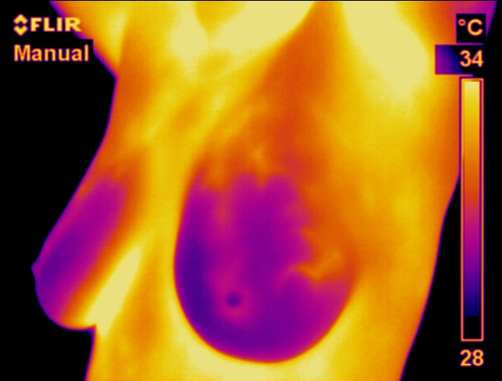
Digital Infrared Imaging is a high-tech non-invasive imaging procedure designed to be used by women of all ages. The technology has been thoroughly researched for over 30 years and is FDA approved for use as an adjunctive imaging tool. Its unique ability to play a possible role in prevention is an impressive added benefit. Unfortunately, at this time there are too few qualified DII centers worldwide. However, with an increasing demand for the technology, educational organizations such as the International Academy of Clinical Thermology, International Thermographic Society, and the American Academy of Thermology are providing training for certified technicians and thermologists. It is their goal to provide women with greater access to this lifesaving technology.

Currently, no single screening procedure can detect 100% of all breast cancers. Digital Infrared Imaging is designed to be used as an additional procedure with mammography, and other tests, and not as a replacement. Studies show that when DII is added to a woman’s regular breast health check ups (physical examination + mammography + DII), 95% of all early stage cancers may be detected. This would give the vast majority of women who are diagnosed with this disease the reality of returning to a normal healthy life.

What if we could add another procedure that may act as an early risk marker for this terrible disease? What if we could provide a multimodal approach that includes technologies that increase the early detection process? Would this give women a better chance for survival? The number of women who die from this disease will change very little if nothing is done to provide a better system. Digital Infrared Imaging has the unique ability to warn some women far enough in advance to give them a fighting chance. Combined with its ability to play a possible role in prevention, the advantages are obvious. With the addition of DII to a woman’s regular breast health care, women of all ages are given an early detection edge in the battle against breast cancer.
What if we could add another procedure that may act as an early risk marker for this terrible disease? Would this give women a better chance for survival?

About the authors:
William Hobbins, MD, a Fellow of the American Board of Surgeons and a board certified clinical thermologist, has been performing thermal breast imaging for over 40 years. As an internationally recognized authority in this field, he has sat on multiple medical and thermographic boards, authored numerous articles, and has contributed a significant amount of research to the medical database using this technology. He currently practices in Madison Wisconsin.

William Amalu, DC, a Fellow of the International Academy of Clinical Thermology and a board certified clinical thermologist, has utilized digital infrared imaging in practice for over 20 years. He is currently the President of the International Academy of Clinical Thermology and the Medical Director of the International Association of Certified Thermographers. Dr. Amalu is in private practice in Redwood City California. For more information, please go to www.breastthermography.com.

